ADMISSIONS AND SCHOLARSHIP DAY
Name: Collins Kinyua ireri
School: Lenana School
Phone: +254 705 051 135
E-mail: legendireri@gmail.com
Face book: Ireri Kinyua
Instagram: Legend. Ireri

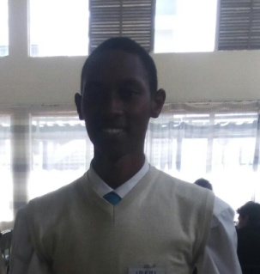

I honestly love challenges and I always believe that once I face a challenge, when a similar one comes along it would be easy to solve. Having attended a few AKAD events I was more confident in my abilities and I couldn’t wait to put the value addition AKAD has had on me so far to practise. If I only knew what awaited me I would not pick white for an outfit for starters.
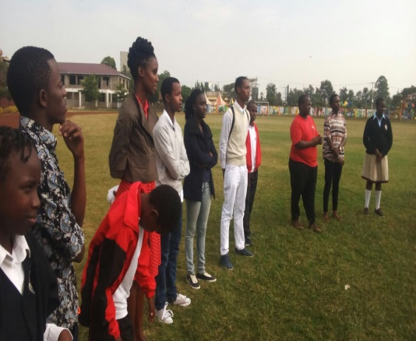
Getting to MOW in south C, the location of the day’s event was no longer a challenge despite this being my second time to visit the place, all courtesy of AKAD. This time I didn’t even find the team building activities as mind boggling as the first time, it was actually fun to solve the puzzles for I had a powerful secret weapon, my imagination, Albert Einstein quotes, “Imagination is more powerful than knowledge.”
Figure 1: Team Building activities are always good ice breakers

The first session was information about AKAD and its value addition, Rv. Dr. Julius Weche, Chief Executive Officer of the organisation requested volunteers to testify of how their journey with AKAD has been.
Erick Fairweather was first to speak and what really caught my attention was, “I am not where I want to be but I am better than where I was,” they may not be his exact words but that is what I interpreted what he was saying to mean. He had no idea how this was a reflect of what AKAD had done to me.
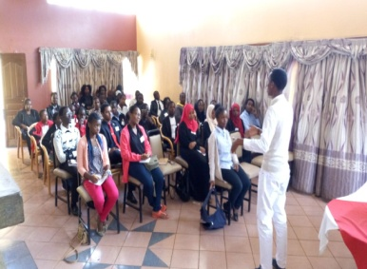
I was here to showcase value addition hence there was no perfect opportunity to do this than in this session, I was nervous to be sincere however I noted a difference. Positive difference to be accurate and I realised that my life was taking a totally different turn to what I would’ve imagined four years ago.
Figure 2: i was more than delighted to give an account of my journey with AKAD

Michael Mutie, a student at African Leadership University, an AKAD youth mentor made his account before he headed on to NTV to participate on a debate about how ambitious Millennials are. It came as a shock to me since all my achievements in life revolved around my ambitions.
His was simple as he sensationally articulated his life story and his confidence was outstanding. His humble background did not hinder him from achieving his goals and was a clear proof that the sky is no longer the limit for there are things beyond the sky.
The ladies were not left behind as they also had their own amazing stories to share. Mercy Kamau, an AKAD mentor mentioned that if what you are doing does not make you excited to get up early then it is not worthy of your time.
The break was tragic and I am pretty sure I hate tea now, an incident made me miss most of the next session. I accidentally spilled tea on my white trouser and I will never forget the hectic time I had trying to remove the stain.
The stain never came off unfortunately, I made it worse. However, I met new people and I found it astonishing how it was easy to start a meaningful conversation with a stranger and become friends, I was delighted to make a new friend, Rosemary who works at the sports club.
Back at the hall Josphat Lowoi, a student at Duke University, was speaking to those in attendance of how to get admitted to world class institutions.
He involved those in the room who had also had the pleasure of being accepted to these world class institutions to make their contributions. Although I missed most of this session, I will follow up on it since I was able to obtain his contact.

The afternoon was a pleasant one as Catherine Njeri in partnership with Michael Mutie; both students from African Leadership University gave us an account of their university including their vision and mission. This wrought an interest in me with their university as their learning model is one I admired.
Professor Mugendi k.M’Rithaa’s session was one to recon with as he showed to us the impact of industrial design in Africa and I realised that afrikans have the solutions to their problems they just need to believe in their solutions.
This day was another example of the value addition AKAD has had on me I made networks, came up with new solutions and most of all learnt on World class institutions and their learning models.

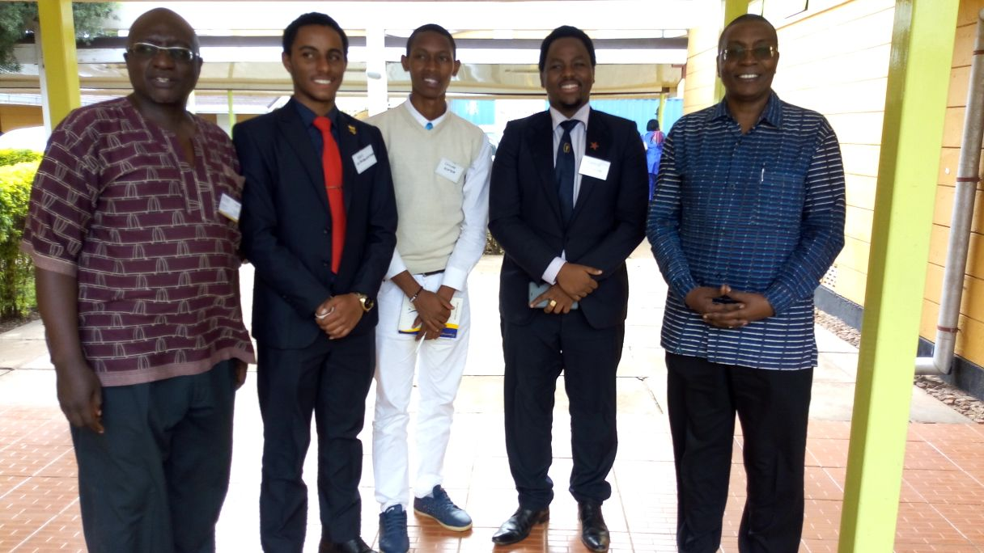
Figure 3: from left, Rev. Dr. Julius Weche, Erick Fairweather, me, Francis wahome and Professor Mugendi... it was an alumni affair.

