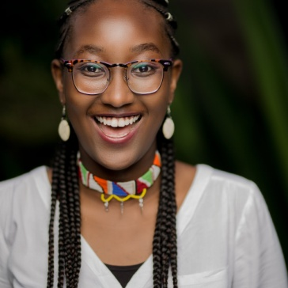
Aaliyah Iqbal
Email:iqbalaaliyah20@gmail.com
Facebook: Aaliyah Iqbal
Instagram: the_name_is_iqbal

Admissions and Scholarship Session 2018:11th January 2018- MOW Sports Club
I had marked this day on my calendar since the beginning of the year and I had no doubt that it would give me the inspiration I needed to push through the new year. The day began with team building where we gave each other a chance to introduce ourselves and participated in activities such as knotting our hands and detangling them without letting go. I must say this was such an ingenious way to start the day as bonds between the participants were created, literally!
The session began with Dr. Weche highlighting the meaning of mentorship and what it means in everyday life. AKAD mentors gave us their testimonials on what mentorship means to them and these stories inspired me a great deal. They inspired me to the extent that I gathered up the courage to tell the audience what mentorship means to me and what I expected to gain from the talk.
Josphat Lowoi, a keynote speaker in the day’s session, commandeered the floor. He spoke about the application process to US universities. This was primarily because early last year he got accepted into Duke University on a full MasterCard Foundation Scholarship. He shared with us his courageous life story and the strategies he used to get to where he was today. I learnt the power of self believe and consistency from his life’s achievements. He also emphasized on the importance of mentorship and friends in his life. We had a question and answer forum where we discussed matters involving the various sections of the Common Application (the portal that one signs in to upload all necessary information required by most US universities). In between this session we paused to listen in on Michael Mutie’s interview with Victoria Rubadiri on NTV. It was an interesting and relevant discussion posing the question ‘Are Millennials a lazy generation?’
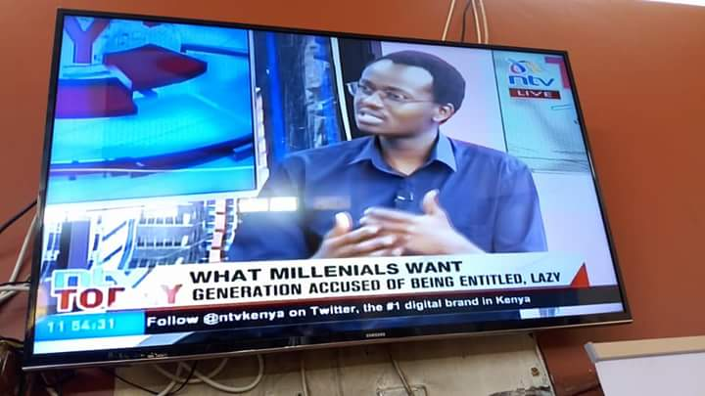
Michael’s interview with Victoria Rubadiri.
We broke for lunch where we had meaningful conversations with one another as we tried to gobble down the scrumptious food before the next session began. Fresh from his interactive interview, Michael took to the stage to give us a presentation on African Leadership University (ALU) accompanied by Catherine Njeri.Michael is a third year Computer Science student while Catherine is a third year student pursuing Electric and Electronic Engineering. They both presented the structure and ethos that ALU follow and proved to us why it is considered as the ‘Harvard of Africa’. Through them, I was able to visualize life abroad and all the new vistas of life that these experiences open for an individual.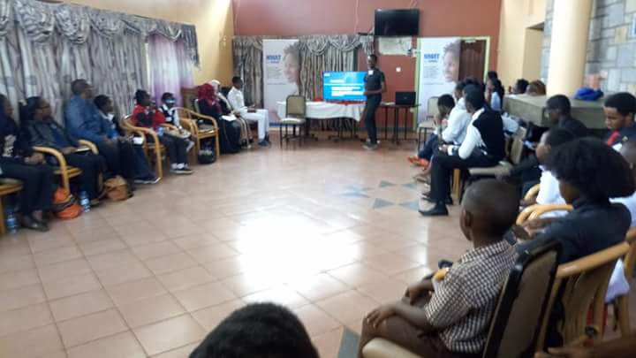Michael and Catherine’s presentation on ALU.
The last segment of the session was delivered by Prof. Mugendi. He is a Professor in the Department of Industrial Design, Faculty of Informatics and Design, Cape Peninsula University of Technology (CPUT) and a holder of a PhD in Universal Design. He highlighted an intriguing slide presentation on universal design infused with African culture. He also shared with us insights on various sayings from different parts of the continent and explained the importance of Universal Design in this era. He urged each and every one of us to believe in our passion and to see it to completion. What caught my attention most was his love for the youth and the way he holds our opinions and ideas with high reverence.
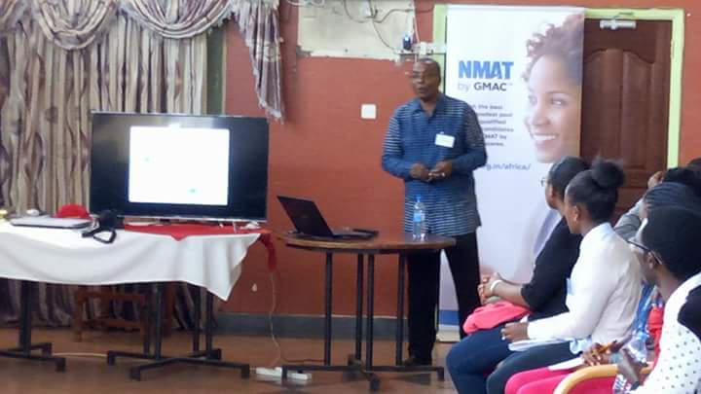 Professor Mugendi explaining his presentation to the audience.

The productive day came to an end with most of us exchanging contacts and planning on a bright future amidst all the knowledge and inspiration we had gained. I remember saying goodbye to my new friends for the umpteenth time because I wanted the day’s events and feelings to be perpetual. This was truly a fantastic experience and I look forward to be a part of the next AKAD event, to be inspired like I was on this day!

