Name: Mark Saruni
School: Lenana School
Email: makosa.msk@gmail.com
20TH AKAD CAREERS SEMINAR
Leadership and youthprenuership are a key to successful future lives. Leadership skills will make a person stand out as an extraordinary leader when compared to a handful of other leaders. Youthpreneurship on the other hand is simply an entrepreneurial culture among the youth. The 20th AKAD seminar that was held at the Management University of Africa tackled these two vital topics to the very best. I learnt a lot from the speakers who included; Dr. Weche, Rosemary Wambui, Mr. Derek Bbanga, Sensei, Mercy and Steve of Angaza, Eric Fairweather, Boniface Omina and Duncan Thumbi of Lenana School.
Eric Fairweather talked about sticking to our values like glue. He tackled thee leadership quotients which include; agility, authenticity, sustainability and talent. He also explored leadership theories. These are very much applicable to me as I am a secretary back at school. I have to lead by example, be flexible and compatible with change and try to be as authentic as I can at all times. I also learnt to think first then analyze the situation before making the necessary conclusions based on the evidence at hand. His ending quote was, “To get a man out of his comfort zone, bestow responsibility.”
Boniface Omina, full of enthusiasm, covered leadership effectiveness. This is brought about by self-attributes which comes from our skills and attitudes. He emphasized on being proactive, using our talents and seeking to understand first. This is very practical to me as it forbids me from rushing into wrong conclusions. He believes in the word BUILD. Believe, Understand, Invent, Listen and Deliver. Always showing results is what gives people confidence to keep trusting you.
Duncan Thumbi was up next. I got the privilege of welcoming him to speak by reading out his profile. He is the actual reason as to why I joined AKAD. He is my class prefect and this is not just displayed by the badge he has on his chest each day, but by the fact that he walks the talk. He talked of accepting failure. “I don’t fail,” he said, “I succeed in finding ways that do not work.” I learnt the virtue of accepting and embracing failure and turning the stumbling blocks of life into the stepping stones of success.
Angaza coaches, Mercy and Steve, were responsible for the fun activities that went down during the seminar. They taught on trying something out first to see if it is doable then leading people through the steps to succeed in doing it. I also learnt that 60% of my character is expressed non-verbally and I should strive to ensure that I do not pass the wrong message through my actions. I learnt to study people and even working in a team. (The activity whereby we were blindfolded and led through the valley of death and through two strings)
I also learnt about setting an objective in life. Mr. Derek Bbanga said that his daily aim is to be the smartest man in the room. Being C.E.O. of Public Image Inc., he mainly dealt with public presentation. “The first impression is the lasting impression.” Derek dealt with personal Branding. I have to have a well-defined brand. What do people say I am? My brand should also evolve (be flexible) in order for me to remain authentic. He said we should develop our KASH: knowledge, attitudes, skills and habits. Skills such as public speaking can be develop by having the three E’s; Energy, Enthusiasm and Enjoyment. Our destinies are a product of our thoughts. This is because, thoughts become words, words become actions, actions become habits, habits become characters and the characters become our destinies. This comes in handy in changing my school of thought. Positive thoughts, bright destinies. Derek finished with, “Fake it until you become it.”
Rosemary Wambui, an AKAD associate, dealt with a myriad of topics throughout the seminar. This taught me the value of embracing challenges. On radicalization, she insisted on knowing our true selves. When dealing with strangers, vagueness should never be entertained. In fact, strangers offering opportunities should be met in person. The topic of discussion should be well considered before making rush decisions and many questions should be asked. After consideration, reach an agreement.
Madam Wambui also dealt with working in a team. We should know our team mates. When you know those who are with you, you will definitely know those against you. I also learnt that competitors are the most important people in life. They never let us rest hence taking us out of our comfort zones. Teamwork will surely be beneficial to me when time comes to starting my own Newsroom. Currently, I will start applying it in school through group discussion and clubs.
FAITH. This was her strategy to succeed in bettering oneself. Being Faithful to goals, being Available for mentorship, taking Initiative, being Teachable and being Hungry for the desired goals. She also talked on changing our mindset. Some uncouth mindsets limit us from stretching out to our goals. A positive mind brings positive ideas that bring positive change. She told me to write down my goals and evaluate them through the ‘five whys’. To summarize her sessions, I would say that Rosemary showed me that my life depends on me.
Dr. Julius Weche, the man behind the success of the seminar also sowed a seed of greatness in me. He covered financial literacy, planning, investing, and marketing among many other business related topics. He gave us tips to succeed in life for example; become aware of something, understanding it, believing it can be done and then acting. I learnt that change fails because of many reasons. People have no vision, no sense of urgency, no short term wins, under communication and often leaving out the elephant. (Ignoring the challenges.)
The change process starts with denial then anger then resistance to the change and change comes when it is accepted. I learnt to evaluate the BOTNAs, the WOTNAs and ZOPAs of life. We saw the conflict graph later on. It escalates to maturity and the only way to de-escalate it involves accepting the mistakes and asking for forgiveness.
A fellow mentee drew the ‘why worry’ flow chart that involved:
NO--------------- Do I have a problem------------YES------------can I do anything about it
THEN WHY WORRY ----------------------------- YES/NO

Finally, the tough blows I received during Sensei’s session toughened me for the life ahead.
The seminar has made me completely different from who I was. Just like in a self-defense session, I bow in honor of AKAD who will continue to be the light in my pitch-black night of unexposure.
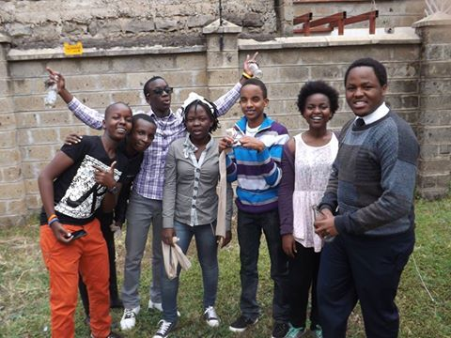 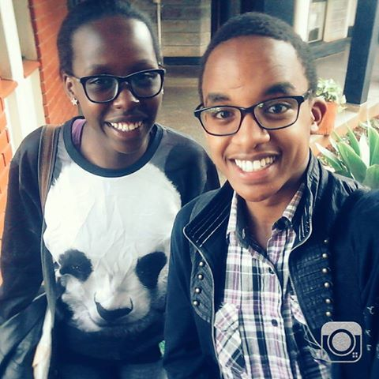 Me with a fellow mentee Desiree
Pic 1; Team Lit in the activities.
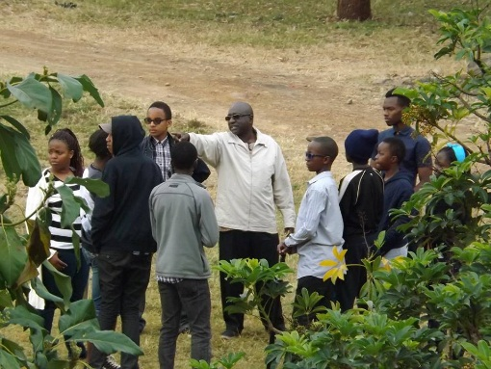 Precautions during terrorist attacks with Dr Weche

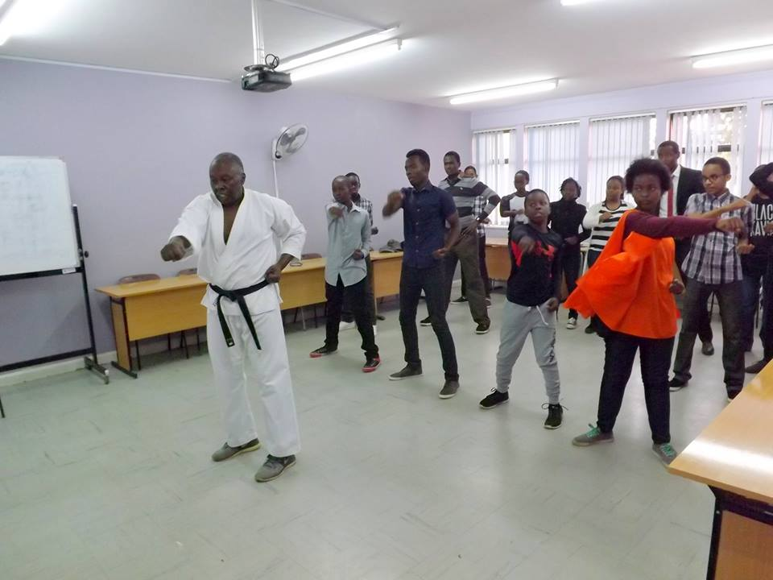Sensei’s session on self defence.

